- Implemented features/completed work and design decisions

In this sprint, we focused on the additional features and frontend implementation.

The flask backend application has been almost done, which is able to return the desirable data after testing using postman.

For the additional features, we have implemented all the 3 features in an essential form. Langchain framework is used for AI chat features, as well as using the API provided by Aliyun. Besides, chat history storage and memory of large language models are achieved by creating new tables in the database. When a user logs in, the chat history is displayed, allowing the user to select from the history chat list.

For the frontend, it’s updated to display the available bikes and stands data when hovering over the station icon. The request is sent automatically when visiting the website so there is no latency when the user hovers over the icon to see statistics.

Besides, a problem has been spotted because of the computing resources insufficiency. Our Mysql database was operating in the form of docker container, but plenty of data has been written into it, leading to time out when performing querying and interacting with database. We finally solve this problem by migrating database application from EC2 to RDS, which is provided by AWS, therefore sql statement can be executed within fairly short time.

Thanks to the usage of CICD, namely Jenkins, our production application keeps the newest version during the process of development. We still harness docker and containerization deployment technologies to pursue a more professional and normalised process.

- Burndown Chart
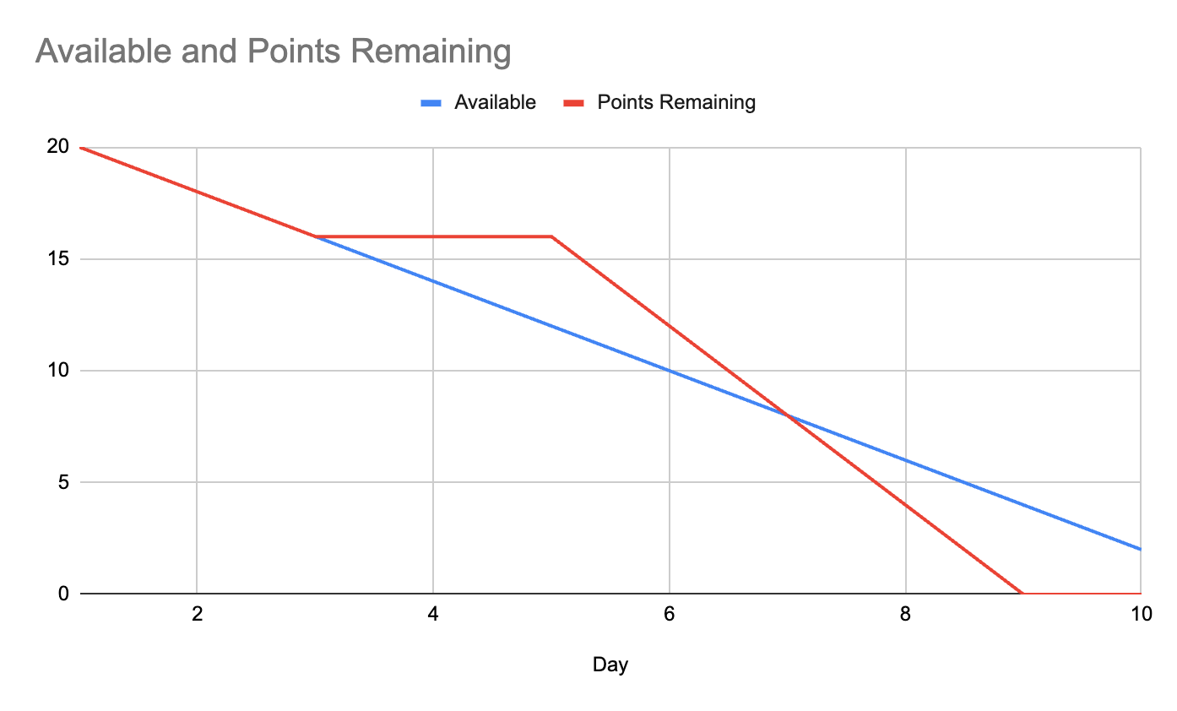
- Sprint Review

AI Chat Features: Successfully implemented the three core AI features using the Langchain framework and Aliyun API. Demonstrating chat history storage and LLM memory through new database tables, with chat history displayed upon user login.
Backend Completion: The Flask backend application is nearing completion, successfully returning the required data, confirmed through Postman testing.
Frontend Data Display: Updated the frontend to display available bike and stand data upon hovering over station icons. Data requests are now automatically sent on website load to eliminate display latency.
CI/CD & Deployment: Verified the continuous integration and deployment process using Jenkins. Confirmed the use of Docker and containerization for a professional, normalized deployment process, keeping the production application updated.

- Sprint Retrospective

What went well:
The basic functionality of features are working successfully. Collaboration of frontend and backend are perfect and errorless. Procedure and workflow are designed to be normalized, both development and production environments are configured properly, teamwork of coding, reviewing also operate in an ideal state.

What could be improved:
The design of UI and UX could be improved by using more professional tools. The color scheme is also not considered good enough, requiring more research and attempt.
The API key used for bikes statistics and google map could be leaked in the frontend console, which can be a great risk for production and commercial usage.
The output of AI chat might be stopped if the user refreshes or closes the webpage when LLM is printing words. It can probably be fixed by adding one more table in the database to store the response from LLM before returning it to the frontend.

For next sprint:
Front-end beautification: better color scheme, UI and UX could be implemented and taken advantage of to improve user experience.
AI chat bug fix: Output shouldn’t be interrupted once the request succeeds. Persistence of response should be done prior to returning to frontend.
Machine Learning implementation: ML is planned to be used for prediction of availability of bikes and stands.
Tests: Unit test, integration test, e2e test may need to be added, making the project more engineering and aligned with the standard procedure in enterprises.

